Studio Noto - FlytBase Sentinel

Round 1 — Ideation Direction

1. The Core Problem
At 3:47 AM, emergency response breaks down not because of missing data, but because of blindness and latency.
Operators are overwhelmed by: - raw, low-visibility camera feeds (smoke, darkness) - fragmented information across multiple panels - micromanagement of individual drones
What they actually need is clarity, confidence, and fast coordination — not more controls.

2. Our Design Belief
In emergency response, humans decide strategy. AI executes logistics silently.
This belief aligns with FlytBase’s core brand values of reliability, clarity, precision, and autonomy.
The system is designed to function calmly in high-risk, time-critical environments, prioritizing trust through predictable behavior rather than visual intensity or control density.
The operator’s role is not to fly drones, but to: - understand what’s happening - choose the appropriate response level - coordinate outcomes with confidence
FlytBase Sentinel is designed to support this exact role.

3. The Solution (Operator-Facing Only)
FlytBase Sentinel is an AI-native operator dashboard that replaces: - raw camera feeds → Reconstructed Operational View - drone micromanagement → Response Escalation Control
All critical intelligence collapses into a single operational map on the operator’s screen, ensuring that increasing information density never increases interaction complexity.
The system is designed around what the operator sees, decides, and confirms — not how backend systems function.

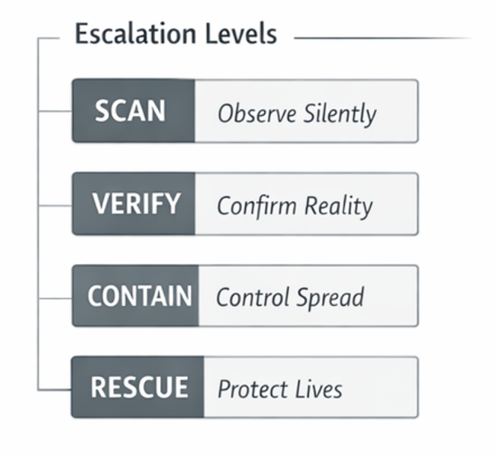
4. Escalation Model (How the Operator Thinks)

Level 0 — SCAN (Passive Monitoring)
What the operator sees: - Calm monitoring state - No alerts unless confidence crosses a predefined threshold
Purpose: Observe silently without unnecessary disruption.

Level 1 — VERIFY
What the operator sees: - Alert with a short verification replay showing how the anomaly emerged - Rising confidence indicator - Reconstructed view instead of noisy video
Purpose: Confirm reality quickly without waking the public.

Level 2 — CONTAIN
What the operator sees: - Fire volume clearly visualized on the map - Impact Boundary showing projected spread - Airspace marked as secured after coordination with airspace authorities
Purpose: Control spread and prepare a coordinated response.

Level 3 — RESCUE
What the operator sees: - Highlighted at-risk homes - Evacuation routes for civilians and ingress paths for emergency responders - Clear authorization flow to alert relevant authorities for public evacuation and emergency escalation
Purpose: Protect human life through coordinated emergency response.

5. The 90-Second Operator Journey
0–15s — Alert & Initial Validation
- Alert interrupts the operator’s current task
- Signal Corroboration Snapshot appears:
  - anomaly source (satellite / thermal / ground sensor)
  - detection timestamp
  - live confidence trend (low → rising)
- Status indicator shows: “Autonomous verification in progress”
- Operator opens the emergency response view
Goal:
Answer “Is this likely real?” without requiring manual investigation.

15–45s — Situational Clarity
- First-response drone data begins streaming into the Reconstructed Operational View
- Smoke-free spatial model shows:
  - probable fire origin
  - terrain and structures
  - proximity to assets / residences
- Confidence updates continuously as new data arrives
- AI pattern match labels appear subtly (e.g. “Vegetation fire signature”)
Goal:
Answer “What is happening and where exactly?”

45–75s — Decision & Escalation
- Operator adjusts the Response Escalation Control (SCAN → VERIFY → CONTAIN → RESCUE)
- System presents a Pre-Execution Preview:
  - planned drone actions
  - predicted impact boundary
  - authority notification scope (if applicable)
- Operator explicitly confirms escalation
Goal:
Answer “What level of response is justified right now?”

75–90s — Supervision
- System executes autonomously
- Operator monitors:
  - exception alerts only
  - confidence stability
  - authority acknowledgment status
- Event timeline updates silently in the background
Goal:
Answer “Is the system doing what I approved?”

6. Trust, Safety & Documentation

Planned Action Overlay
The operator can see what the system plans to do next, represented as subtle overlays with brief contextual labels. This maintains transparency without demanding attention.

Background Autonomy Feedback
The interface provides quiet confirmation of background AI actions (for example, filtered false positives) without interrupting the operator’s workflow.

Event Timeline & Documentation
Every alert, operator decision, system action, and authority notification is automatically recorded in a read-only event timeline.
This documentation supports: - post-incident analysis - regulatory and legal review - evidence and accountability
Live decision-making is never disrupted by documentation requirements.

7. Resilience by Design (From the Operator’s Perspective)
- Operator Fallback Protocol: If no acknowledgment is received, the interface indicates that a safe default containment response has been initiated and a backup operator has been notified.
- Offline Continuity Mode: In case of connectivity loss, the operator sees the system switch to autonomous tracking with delayed updates.
- False Positive Protection: Known permitted burns are visually marked as monitor-only rather than triggering emergency escalation.

8. What FlytBase Sentinel Intentionally Does NOT Show
To preserve clarity under pressure, the operator never sees: - individual drone flight controls - raw telemetry tables - battery and hardware stats unless a failure occurs - non-actionable system data during active emergencies.
This restraint reflects FlytBase’s brand personality — commanding yet passive, assured rather than alarming, and purpose-driven instead of decorative.
Visual silence and coordination are treated as indicators of system confidence, not absence of intelligence.
This restraint ensures the interface remains calm, focused, and usable when seconds matter.

9. Brand Direction (Supporting the System Experience)
A. Brand Positioning
FlytBase is positioned as an enterprise-grade autonomous operations platform built for clients facing high-stakes, real-world problems.
Its brand prioritizes professionalism, reliability, and precision, ensuring customers feel confident entrusting FlytBase with mission-critical operations.
The FlytBase brand communicates:
- Stability over experimentation
- Reliability over expressiveness
- Precision over complexity
This positioning reinforces FlytBase as a platform organizations can depend on when failure is not an option.

B. Brand Personality & Principles
FlytBase’s brand is designed to feel:
- Clean and organized — no visual clutter, no ambiguity
- Professional and enterprise-focused — built for serious operations
- Stable and secure — communicates trust through structure and restraint
The brand avoids playfulness or decorative expression and instead uses systematic, geometric, and predictable visual language to reinforce confidence and control.

C. Logo Ideation Direction
Logo ideation begins with mind mapping FlytBase’s brand attributes aligned with its foundations and positioning.
These attributes are translated into visual keywords such as:
- autonomy
- coordination
- airspace
- precision
- reliability
Competitor exploration across enterprise and aviation brands helps identify visual directions that are credible and appropriate for the industry.
Initial sketching focuses on combining selected attributes into logo concepts that:
- convey enterprise strength
- feel stable and engineered
- work across both dark command-center interfaces and light backgrounds
Final logo execution is intentionally deferred to ensure alignment with the finalized UI system.

Closing Statement
FlytBase Sentinel is not a dashboard of drones.
It is a decision surface for emergency coordination, designed for the exact moment when clarity, trust, and speed determine outcomes.

